Title Qualification Testing of High Temperature Coatings
Author Dik Betzig, Hi-Temp Coating Technology
Source 13th Middle East Corrosion Conferance
Copyright HTC, Dik Betzig

Abstract:
Engineers and designers of elevated operating temperature systems and equipment have a wide choice of testing standards for selecting coating systems for protection against hot cyclic corrosion of carbon & stainless steel. There is no general consensus on standard test protocols.

There is also a lack of agreement as to what standards should be used. Coating specifiers for major oil and refining companies have yet to develop a consensus as to what the physical performance guidelines should be for high temperature coatings.

This paper will review various test methods currently used by suppliers in the industry. Tests discussed will include ASTM D2485 [thermal shock] “Houston Pipe” [gradient heat] ASTM G189 [CUI Test] ASTM E2402 [mass loss] HTC [CUI cell].

An important obstacle to predicting corrosion is the variety and combination of corrosive environments, which greatly affect the expected service life of any coating system. Ease of application, installation and tolerance for expected future increases in operating temperatures, and ability to be repaired after a number of years of service will also be presented.

Overview:
Coating evaluation procedures fall into four general classes:

- Standard characterization,
- Nondestructive testing screening
- Environmental stimulation.

Standard characterization tests are those that measure basic characteristics of a coating and/or the coating-substrate composite. This would include the measurement of such properties as hardness, thickness, density, melting point, emittance, thermal conductivity, tensile and creep strength, elastic modulus, and fatigue strength. Many of these measurements are routing procedures for which there are ASTM standard test.

Screening tests are generally designed to provide a preliminary evaluation of the capability and potential of a coating system for a given application. Usually the data derived from such tests are of a comparative correlative nature. The test environment ordinarily includes only one or two independent variables and is geared for high rate-high volume rather than environmental simulation.

While screening tests normally involve a minimum of equipment, some facilities, notably those which are used to screen Expensive process equipment gas, may represent capital investments exceeding $50,000. Perhaps the most common screening test for high temperature coatings is the so-called cyclic oxidation test in which small coated tabs are subjected to a series of isothermal air exposures until the original lot of specimens has failed. This test, like other screening test, can be quite effective in eliminating from further consideration ineffective coatings; thereby minimizing the number of candidate coatings that must be carried into advance proof testing. Simulated environmental tests are those in which the used environment is simulated in the laboratory. This description is somewhat of a misnomer since most environments are too long in duration to be realistically modeled.

Another elusive factor which complicates interlaboratory data comparison is failure criteria. The appearance of substrate oxide has been generally regarded as evidence of coating failure. However, the amount of oxide that accumulates to constitute a failure is a subjective quantity and will vary from laboratory to laboratory. Moreover, this failure criterion is strictly artificial and may have no relevance to what would constitute a service failure.

The first step toward elimination of the current confusion is evaluating coatings would be establishment of meaningful test standards. An effort of this nature has been the subject of earlier studies. Establishment of test standards for high temperature protective coatings is currently being investigated by ASTM committee C-22.
The test procedures have received only limited acceptance; the progress of ASTM C-22 has been relatively slow. This is due, in part, to the reluctance of laboratories to discard self-developed test procedures in favor of new and unfamiliar routines. Eventually, tests will be standardized, but not in the near future.

The confusion and inefficiencies caused by the current lack of test uniformity can only worsen as coating requirements become more stringent. Higher operating temperatures, longer service life, and great reliability will be demanded of future coatings. Improved measurement techniques, refined reliability analyses, and more effective NDT must be developed.

Heat Resistance of Organic Coatings:
When organic coatings are exposed to elevated temperatures, the initial effect is usually softening, followed by hardening, embrittlement, and degradation. The rate of response and the extent of degradation depend on coating composition, temperature, and length of exposure. There is a distinction in the terminology used to define the resistance of coatings to such changes. Below 400F (200C) the property is called “thermal resistance”, while above the temperature the property is identified as “heat resistance.” Both thermal and heat resistance relate not to occasional heating, but to resistance to change from exposure to a constant heat influence over months of years.
Special organic coatings can be formulated to provide thermal resistance, such as those designed to protect steel surfaces exposed to elevated temperature during service life. The upper temperature limit for most organic coating is in the range of 400F (200C).
Epoxy phenolic, vinyl esters and novolac epoxies, will offer good long-term corrosion protection. However; they are over rated in terms of temperature and loose mass in the order of 20-30% with prolonged exposure above 150C [300F].
Traditional thin film silicones and aluminum silicones perform best in dry isothermal conditions and will not tolerate intermittent emersion.

Heat Resistance of Inorganic Coatings
In general inorganic/ceramic coatings exhibit better heat resistance than organic coatings. Zinc silicates react with warm and wet insulation in a cyclic environment and are not the product of choice for CUI applications. Most of the current inorganic including TSD [thermal spray aluminum] coatings have a high degree of porosity and perform best under steady state thermal conditions, and are affected by salt spray under cyclic conditions.

A special group of products are thermal protection coatings, including ablative coatings to protect space vehicles during atmospheric re-entry and intumescent coatings that protect wood or other cellulosic surfaces exposed to fire.

For elevated temperature service, newer technology systems which can be applied in the fabrication facility and allow for transportation and erection with little damage are available. These technologies can be used to overcoat inorganic zincs or – preferably- can easily replace inorganic zincs as these new technology coatings become hard and resist damage, do not require a heat cure to develop corrosion preventative properties and are easily repairable with themselves after erection and welding or bolting up of the equipment. Not all technologies have this longer recoat window, so specifiers should familiarize themselves with each product’s technical data sheet. Not all new technology products develop a hardness level that allows for post fabrication and painting handling, erection and fitting. The specifier should be very careful to ascertain this physical property characteristic of the newly applied coating.

 | Traditional Elevated Temperature Silicones | Multi-polymer Primer | Novalac Elevated Temperature Epoxies | Inorganic Zinc | Inert Multi-Polymertic Matrix | Thermal Spray Aluminum
Anodic metal sacrifices in electrolyte | Yes  (Aluminum) | Yes  (Aluminum) | No | Yes  (Zinc) | No | Yes
Intermittent immersion in salt water | Fails | NR | Yes | Fails | Yes | Fails
Hot apply ˚C | Yes  93˚C  200˚F | Yes  120˚C  250˚F | Yes  120˚C  300˚F | No | Yes  260˚C 500˚F | Yes
Surface tolerant | No | No | No | No | Yes  SSPC  SP-2 | No
Typical Organic & Inorganic High Temperature Coatings

Surface Preparation & inspection
Surface preparation is of course one of the most important parts of the coating system selection. It is generally a more costly component of the work and can involve not only hazardous waste generation, but can require health and safety precautions. In many cases the choice of surface preparation mechanisms can become a limiting fact in evaluation of projects and engineers estimates. Some of the new technology CUI coating systems do not require the typical white metal clean surface preparation efforts, and can work well in a less then optimum application.
It is important to have an inspector on site as an extra set of eyes during the surface preparation and coating system application. This will aid in ensuring that the coating system applied is installed in accordance with the owner’s specification and product data sheet. With the overall cost of doing this work, it is extremely important that the coating system works as well as possible so that it does not have to be reapplied in short order. Life cycle thought processes are important in choosing the coating system and by ensuring a proper application, realization of these expectations can be achieved.

Test Methods for Evaluation of Heat Resistance
Evaluation of heat resistance is carried out on coated specimens exposed to selected temperatures representative of service conditions and later subjected to other exposure conditions to determine susceptibility to loss of protective function.

ASTM Method D 2485
Typical of this kind of testing is ASTM Test Methods for Evaluating Coatings for High Temperature Service (D2485). This method provides an accelerated means of determining performance when coatings are exposed to high temperatures.
In Method A, for interior service coatings, coated steel panels are heated for 24 hours in a muffle furnace at a selected temperature. One panel is plunged immediately into water for thermal shock, while another is cooled and then subjected to a bend test.
In Method B, for exterior service coatings, coated steel panels are heated in a muffle furnace at increasing steps of temperature from 400 to 800 F (205 to 425C). One panel is subjected to salt spray for 24 h, while another is exposed outdoors for twelve months. When test exposures are completed, the panels are examined and evaluated for film degradation including rust formation, blistering, loss of adhesion, dulling and chalking.

ASTM Method G189
1.1 This guide covers the simulation of corrosion under insulation (CUI), including both general and localized attack, on insulated specimens cut from pipe sections exposed to a corrosive environment usually at elevated temperature. It describes a CUI exposure apparatus (hereinafter referred to as a CUI-Cell), preparation of specimens, simulation procedures for isothermal or cyclic temperature, or both, and wet/dry conditions, which are parameters that need to be monitored during the simulation and the classification of simulation type.

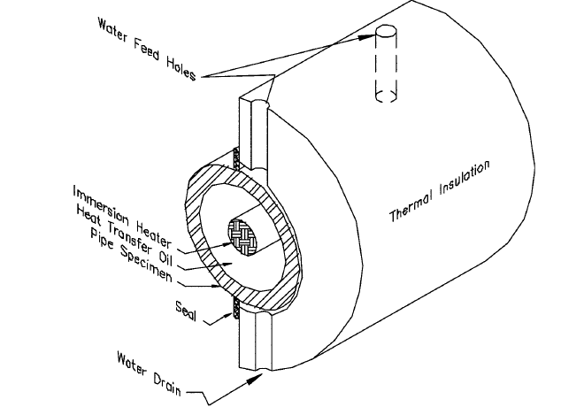
ASTM G-189 cross section of test cell

The application of this guide is broad and can incorporate a range of materials, environments and conditions that are beyond the scope of a single test method. The apparatus and procedures contained herein are principally directed at establishing acceptable procedures for CUI simulation for the purposes of evaluating the corrosivity of CUI environments on carbon and low alloy pipe steels, and may possibly be applicable to other materials as well. However, the same or similar procedures can also be utilized for the evaluation of (1) CUI on other metals or alloys, (2) anti-corrosive treatments on metal surfaces, and (3) the potential contribution of thermal insulation and its constituents on CUI. The only requirements are that they can be machined, formed or incorporated into the
CUI-Cell pipe configuration as described herein.
It is the responsibility of the user of this standard to establish appropriate safety and health practices and determine the applicability of regulatory limitations prior to use.

ASTM Method 2402
Mass is the primary dependent parameter and temperature is the primary independent parameter measured by TGA. Mass loss and residue measurements are validated by their direct measurement using thermo-gravimetric apparatus over a specified temperature range using reference materials of known volatiles content as an analyte. Alternatively, validation of a TGA method based upon mass loss and residue measurements may be performed using a specific test specimen as the analyte.

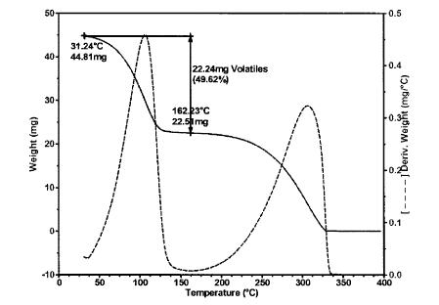
FIG. 1 Determination of Mass Loss for Medium Mass Loss Material

Figure 1 is a typical characterization of a liquid coating system. The first portion of the graft going from 0 to 120C is a result of volatilization of the organic solvents. The mid section of the graft [bell cure 120C to 300C] is related to the binder portion of the coating. Depending on the type of organic binder: acrylic, epoxy, polyester, or polysiloxanes the mass losses will vary with bond strength. Generally after 300C all organics have been reduced to carbon & ash. Inorganic binders and pigments will hold mass beyond 300C.

The mass loss of three or more specimens (nominally representing the maximum, midpoint and minimum of the range of the test method) is measured at least in triplicate. A fourth blank specimen, containing no analyte, is also measured at least in triplicate. Repeatability is determined by performing a sufficient number of determinations to calculate statistically valid estimates of the
standard deviation or relative standard deviation of the measurements.
The evaluation for the Tg of the un-aged epoxy using a DMA instrument showed that the material possessed a Tg of approximately 150˚C based on the peak of the tan delta plot. This result was approximately 7-10°C higher than for what was obtained by the less sensitive DSC method, however differences in sample preparation and thermal history could play a role in affecting the results. From this testing, the coating should be capable of service temperatures as high as 150˚C, however excursions beyond this value do not appear to be detrimental based on the CCOT ageing study conducted at much higher temperatures.

Modified Houston Pipe Test
The original Houston pipe test was developed to study high temperature coating exposed to atmosphere. This test method was also valuable in looking at color stability using a temperature gradient and simulating a stack/flare environment.
Recently this method has been modified to include insulation surrounding the pipe and introducing saline water by injection between the pipe and insulation.


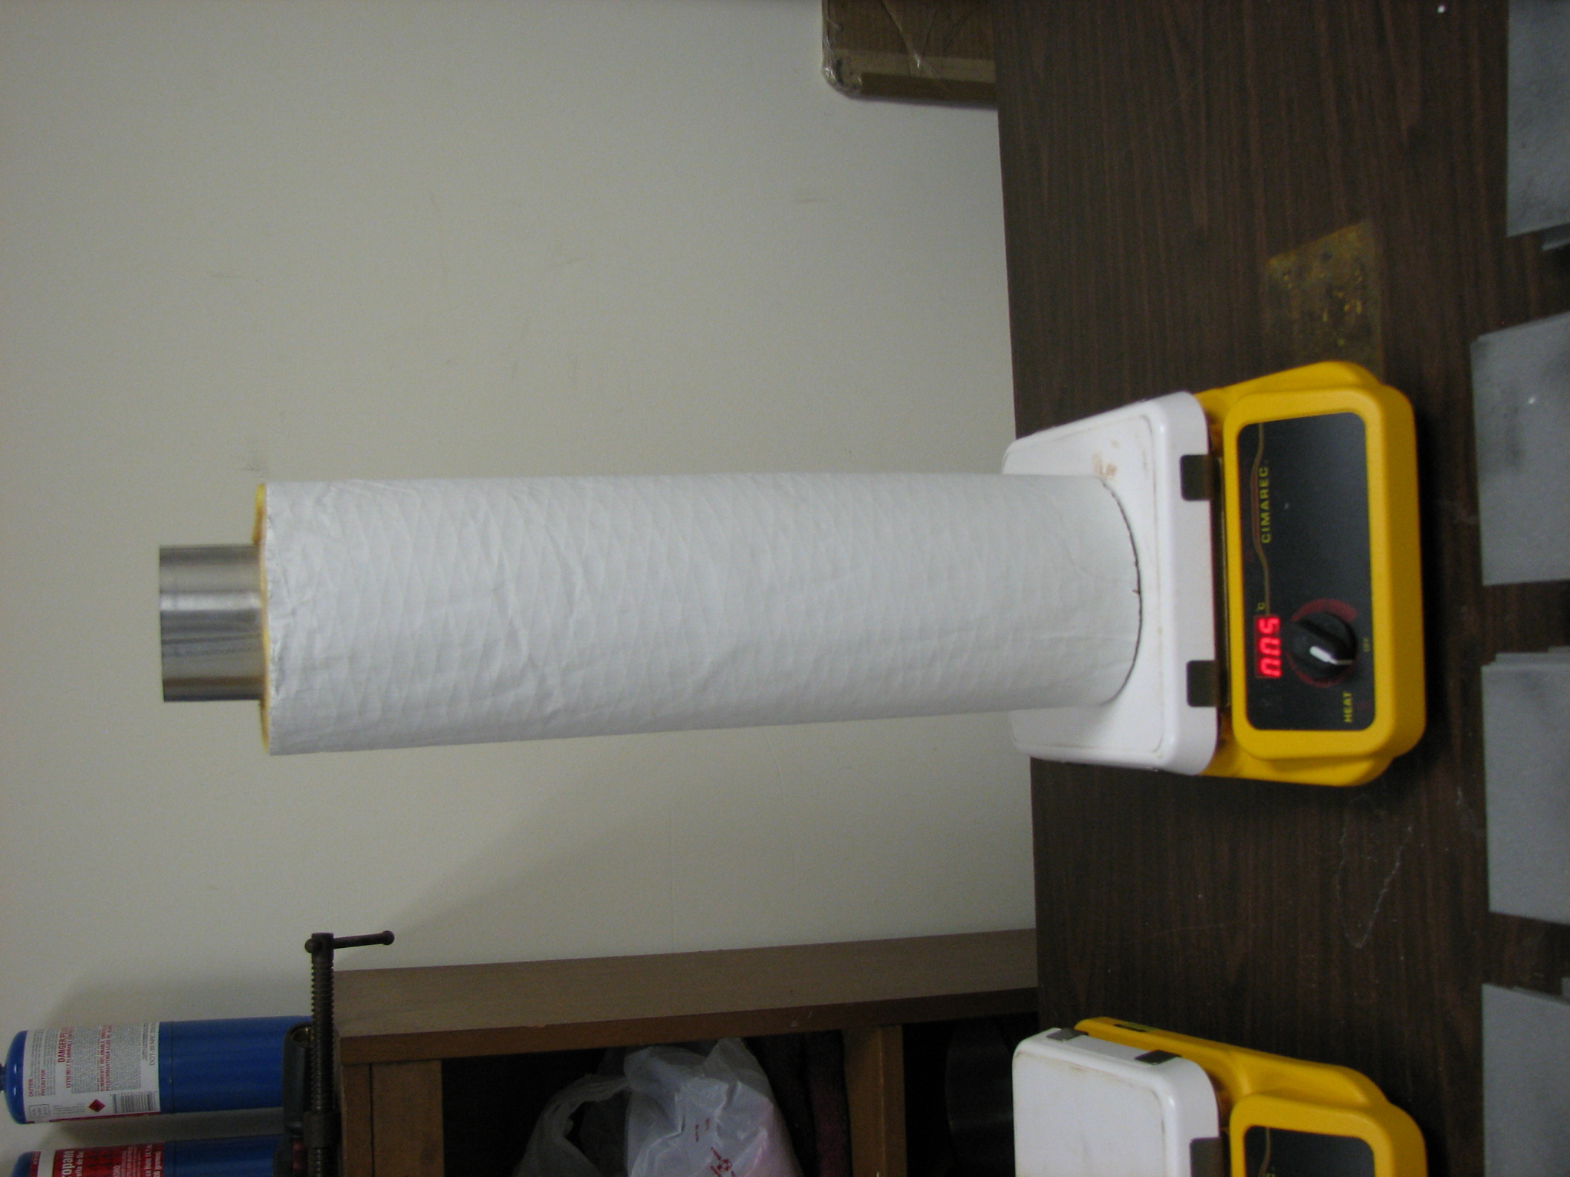
400C
50C
2B Modified Houston Pipe 2A Standard Houston pipe

Figure 2A is the original Houston Pipe test consisting of a 2.5-3.0 inch diameter carbon steel pipe 2 feet long open on both ends. The intent in this case is to simulate an un-insulated flare stack. The lower section of the pipe would be at the highest temperature. The entire pipe would be coated, and the starting temperature would be controlled by varying the distance between the burner and the inlet of the pipe. The duration of the test would typically run for 24 hours. Temperatures at various elevations are recorded and color changes are observed. The final portion of the test involves quenching the pipe specimen in cold water [thermal shock] and examined for de-lamination and cracking failure of the coating.

Figure 2B is the current version of the Houston pipe. In this case the pipe is insulated with high density fiberglass and jacketed with aluminum sheet metal. The purpose of this version is to simulate corrosion under insulation. The temperature of the hot plate is set and thermocouples are placed along the X axis and recorded for future reference. At a pre determined time interval the insulation is saturated with water and allowed to continue until it has dried out, therefore testing for both wet and dry conditions. However this test does not account for elbows and horizontal piping conditions that are present in all plants that will trap water and create intermittent emersion conditions.

The Houston pipe test is economically reasonable to set up and run.
However; temperature control, fluid injection and repeatability are difficult to control. This test is not a good environmental representation for CUI. In its original format the test is suitable for stack and color change analysis.

HTC Environmental Test
The HTC environmental chamber/test was modeled using three major test methods, ASTM G189, ASTM B-117 and prohesion. The best of these test attributes are taken into consideration for this method. Automated Control, uniform heat, accelerated results and repeatability are the essential components to this test method.

The test cell can maintain the set temperature with a minimum temperature fluctuation and even heat distribution due to internal oil circulation system.
Refer to figure 3.

Power
Meter
Heat
Exchanger
Computer
Media
/
Cycle
Control
Pump
Test Cell II
.
Test Cell I
.
Test Chamber
Media Tank

FIG. 3 HTC environmental test flow diagram

The heart of the HTC environmental test is the Heat Exchanger, Cell and chamber. The cell is a carbon or stainless steel 4” x 4” square pipe section 24 inches long with a ¼ inch wall thickness. The cell is placed horizontally in the chamber as shown in figure 4, in a closed loop system. Hot oil from a heat exchanger is circulated through the cell and the temperature is controlled from ambient to 250C. No insulation is used for this test allowing the flexibility for emersion testing.

The test cell is square allowing for flat, vertical and radius geometries. This condition allows the test medium to condense on the top surface and retain moisture during the entire cyclic duration and not dry prematurely refer to
figure 4.

Tempered Viewing Glass
Media
Coating
Hot Plate Temperature Range: 20-250 C
Hot Oil
Vapor State
Seam
Drip Plane
FIG. 4 Cross Section of Chamber and Test Cell

The bottom portion of the cell is under continuous emersion for the duration of the wet cycle. The test protocol is set for alternating wet and dry 4 hour cycles. The vertical surface is scribed to the substrate for undercut corrosion evaluation refer to figure 6.

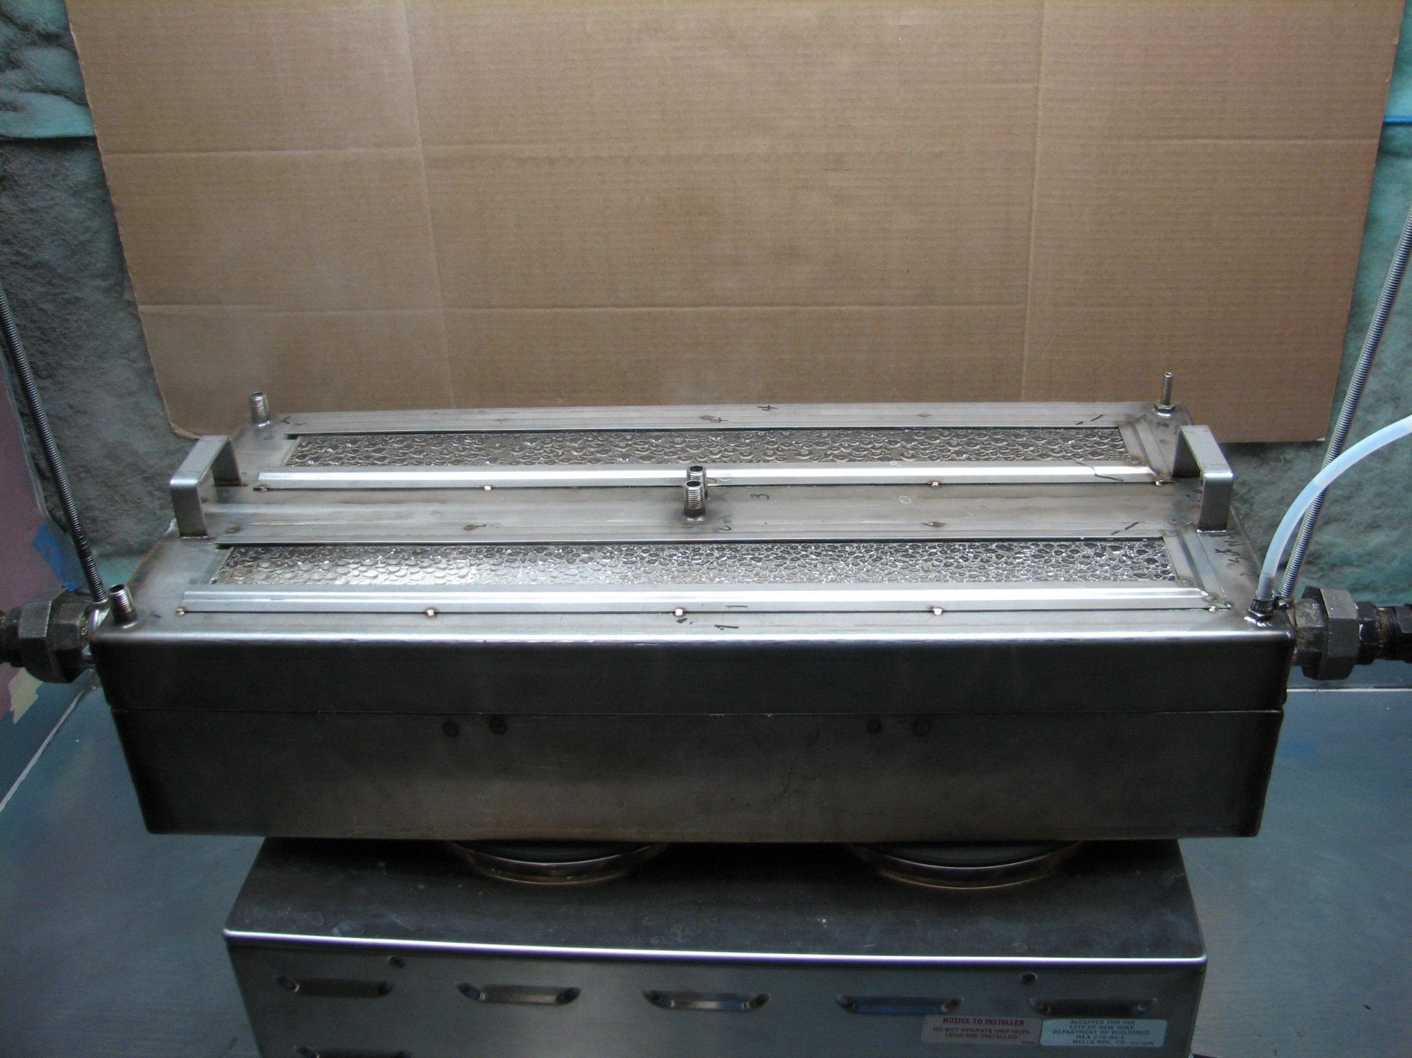
FIG. 5 HTC Environmental Chamber in isothermal condition with wet/dry cycle

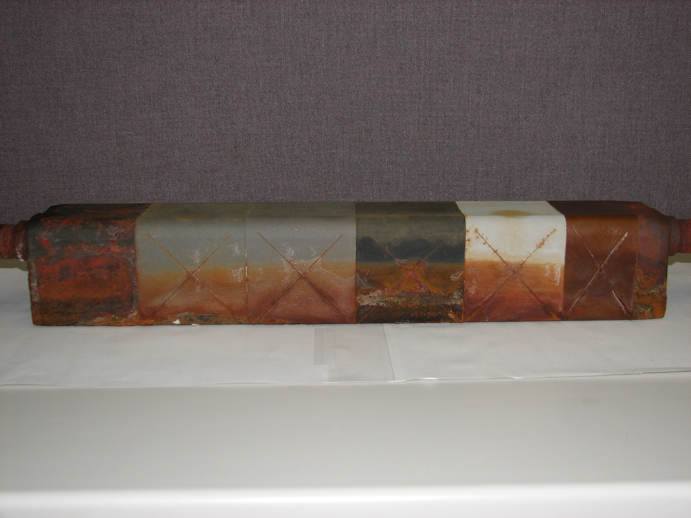
FIG. 6 Carbon steel test cell with various CUI coatings

Summery & Conclusion
It is very difficult to rely on one test method in qualifying high temperature coatings. Accordingly I am recommending the use of 3 distinct methods to determine performance of high temperature coatings.

ASTM 2485: is the first bench mark method that ensures adhesion and matched coefficient of expansion covering the range of temperature and thermal shock performance.
ASTM 2402: Weight loss is critical for long term corrosion performance of high temperature coatings.
HTCEC: Cyclic, isothermal, emersion, salt spray and chemical testing on an accelerated platform are the most important attributes for this test.

References:

- D. Abayarathna, W.G. Ashbaugh, R.D. Kane, N.G McGowen and R.L. Heimann, "Measurement of Corrosion Under Insulation and Effectiveness of Protective Coatings", Corrosion/97, Paper No. 266, NACE International, Houston, Texas March 1997.
- J.J. Hahn, N.G. McGowen and R.L. Heimann, "Modification and Characterization of Mineralization Surface for Corrosion Protection", Surface and Coatings Technology, Submitted for Publication, 1998
- Heimann, R. H. Corrosion Resistant Buffers for Metal Systems. U.S. Patent 5,714,093, 1998
- H. Mitschke, Informal Technology Exchange presentation at NACE Corrosion 2007.
- O. Knudsen, T. Rogne, and T. Rossland. “Rapid Degradation of Painted TSA, NACE Paper No. 04023, 2004
- C. Steely, W. Pollock, “A State of the Art Report of Protective Coatings for Carbon Steel and Austenitic Stainless Steel Surfaces Under Thermal Insulation and Cementitious Fireproofing.” NACE Publication 6H189 1986
- ASTM 106/A 106M Specification for Seamless Carbon Steel Pipe for High-Temperature Service
- ASTM International, 100 Barr Harbor Drive, PO Box C700, West Conshohocken, PA 19428-2959, United States

.

